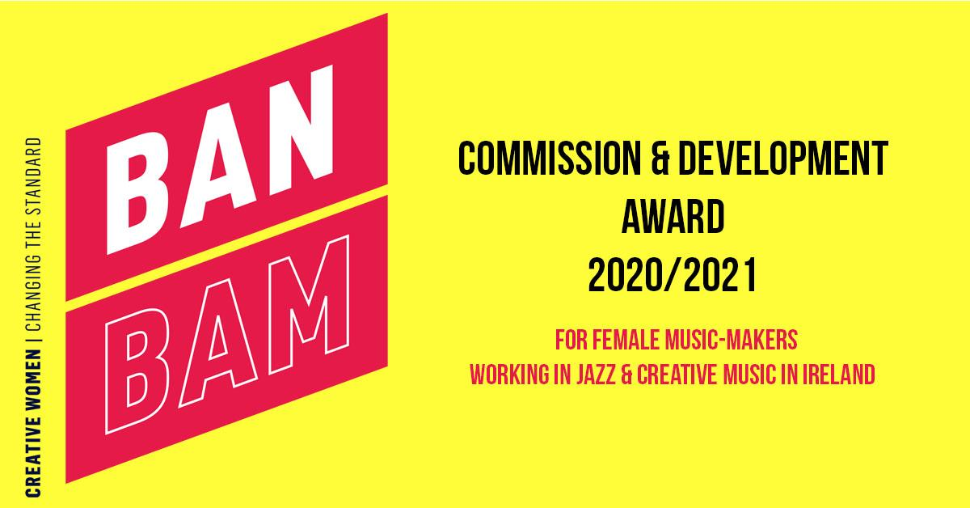

BAN BAM Commission & Development Award 2020/2021
Supporting women in jazz and creative improvised music

BAN BAM Commission & Development Award 2020/2021 is a new creative commissioning and career development opportunity open to Irish-born or resident female and gender minority composers on the island of Ireland (North and South) from Improvised Music Company (IMC) and Moving on Music (MOM).

Following IMC’s ‘BAN BAM’ activity in 2017/18 promoting and supporting women in jazz and improvised music, combined with MOM’s extensive experience with their emerging artists programme, IMC and MOM are pleased to come together with a commission and development opportunity for female and gender minority artists across the island of Ireland for 2020/2021.

Music Commission
This commission is open to female and gender minority music makers who compose in the idiom of jazz, and all creative improvised music.
Three composers will be selected from the applicants. Each awardee will receive a €2,500 commission fee, as well as 12 months of bespoke creative and career development support and consultation from IMC, MOM and selected industry professionals during 2021.
Two awardees will be selected from the Republic of Ireland, and one from Northern Ireland.
The 3 awardees will each compose music for either duo, trio or quartet.
The composed piece can be intended for named artists (ie; duo, trio, quartet, small ensemble), which may include the composer.
Alternatively, instrumentation of the parts alone can be named, with personnel selected at a later date for performance.
The work will consist of a minimum of 10 minutes of composed music, with the possibility of extending the work via improvisation in performance.

Creative & Career Development:
IMC and MOM view this commission to compose new work as a catalyst to further development, and are committed to working closely with the awardees over a 12 month period, developing potential avenues for the work, as well as offering mentorship, career guidance and creative consultation. This aspect of the award will run from January to December 2021 and will be developed to suit the individual needs and ambitions of each awardee.

The award includes guaranteed performance bookings in Belfast and Dublin during 2021, as long as this is feasible in the wake of Covid-19 restrictions. Separate performance fees will be allocated as per industry standard.

GUIDELINES:
Please note applications will only be accepted via an online Application Form.
Applicants must submit the following;

Provide 2 or 3 samples of your existing original work.
Please note, we will only accept your own original compositions.
- At least one sample of existing original works as a score. PDF format is preferable. The works must be reflective of the applicant’s current work.
- Evidence of prior original work (studio or live recording). A URL link to an online location such as YouTube, Bandcamp, Soundcloud (public or private) is preferable, but we can also accept MP3/VIDEO/WAV/AIFF files up to 500MB.

A 1-page CV outlining career highlights to date, education and background.

Complete the Application Form in full, with details of your plans for the composition, potential future development, and your own creative ambitions.
These 3 sections have a maximum of 200 words. We recommend that you prepare this in a Word document or similar and paste into the Application Form.
- The compositional aspect
This can be a broad sense of a structure or theme, including instrumentation.
We are looking for a strong compositional idea and a clear vision in bringing that to fruition.
- A focus on high artistic quality
- Work that exhibits an understanding of technique
- Consideration of /focus on instruments and instrumental interplay (for duo, trio or quartet)
- Performance & further development of your creative vision
We are looking for some information on how you intend for this work to be presented, and any ideas you may have for future development of this piece of music.
- Future ambitions for your career
Please outline how we can help you realise your career ambitions beyond this piece of music

CRITERIA for the assessment of applications:

- Applicants must be born in, or currently resident in Ireland (Rep. and NI)

- Applicants must be over the age of 18 at the time of application.

- These awards are for female or gender minority composers only.

- Applications are assessed in a competitive context and with consideration of the available resources.
All applications are assessed against criteria of;
a) Artistic merit
b) How they meet the objectives and priorities of the award
c) Feasibility and potential of artist and project

Applications will be assessed by a panel of industry professionals and composers, including representatives from IMC and MOM.

If you have any queries about whether you are eligible for this award, please see the FAQs or contact us directly via hello@improvisedmusic.ie

TIMELINE:
The closing date for application is 17:00hrs (GMT) on Friday 4th September, and the awardees will be announced on the 2nd of October 2020.
Late applications will not be accepted.
The composing period is Oct 2020-Jan 2021, with further development, consultations and performance taking place between Jan-Dec 2021.

DIVERSITY POLICY:
The purpose of the award is to assist in increasing the presence of female and gender minority composers and instrumentalists within the Irish jazz and improvised music scene, and to support further collaboration and development.
We welcome applications from members of the LGBTQ communities, all POC and people of any and all ethnic backgrounds and members of the Irish Traveller community.

